**Europe and Japan celebrate major milestone in validating LIPAc**

[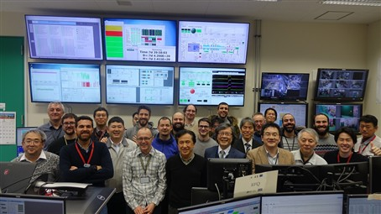](https://f4e.europa.eu/Downloads/News/DSC06312_05082019-050820191200-Large.jpg)

They did it! The team of engineers from the Broader Approach parties involved in the LIPAc tests performed in July, Rokkasho, Japan. They managed to accelerate a beam of deuterium with 125 mA at 5 MeV reaching nearly 90% of transmission.

To get closer to commercial fusion power we need to invest in materials able to withstand conditions similar to those of DEMO, the fusion device that will follow ITER. Europe and Japan have agreed to develop LIPAc - a prototype accelerator to validate the design of the low energy part of a neutron source facility aiming to qualify materials.

A facility has been set up in Rokkasho under the auspices of QST (Japan) working together with F4E, coordinating the European voluntary contributions of INFN (Italy), CIEMAT (Spain), CEA Saclay (France) and SCK-CEN (Belgium). Using a staged approach to assemble and test equipment, a team of roughly 50 people has been giving its expertise and by collaborating with industry they have produced the equipment. LIPAc's Radio Frequency Quadrupole (RFQ), used to accelerate a continuous beam of charged particles with high efficiency, is measuring 9.8 m and is considered the world's longest. Its eight radio frequency lines are supplying a total of 1.6 MW. Earlier in spring, the full set of beam diagnostics had gone through commissioning allowing scientists to measure all of its parameters, ultimately aiming at higher energy beams. End of July the teams gathered on-site to test the beam nearly at full potential. Could they be on the brink of developing the accelerator with the world's highest beam perveance? And that's no easy task because the higher the perveance the more difficult it is to transport and accelerate the beam particle.

A resounding "yes" is the answer. They managed to accelerate a beam of deuterium with 125 mA at 5 MeV reaching nearly 90% of transmission. We asked Philippe Cara, IFMIF/EVEDA Project Leader, what this achievement means for the project. "Essentially this means that our equipment is fit for the requirements of the project. We have proof that we can transport the high-energy beam through the RFQ with minimal losses. This is not only a breakthrough for the project. It is a fantastic achievement for those in the field of physics," he explains.

View of the cross section of the Radio Frequency Quadrupole of the accelerator prototype LIPAc, IFMIF, Rokkasho, Japan. ©T. Shinya

Hervé Dzitko, F4E Project Manager for IFMIF/EVEDA, adds that "LIPAc is the first prototype accelerator delivering a deuterium beam at such density and energy. These results prove that we can transport and accelerate a 125 mA deuteron beam up to 5 MeV- this has not been achieved before.  From a beam physics point of view, the design of all LIPAc components of the low and medium energy part has been validated. The IFMIF accelerator will become the most powerful Linear accelerator (Linac) in the world working in continuous wave."

The LIPAc prototype accelerator, Rokkasho, Japan

Next, the teams will be busy with the installation of the last pieces of equipment of the high energy transport line, and the beam dump, to be able to operate LIPAc in continuous waves in order to validate the entire accelerator at full power. More tests will be performed to characterise the parameters of the beam and provide us with technical knowledge to build the fusion machines of the future.